**PROJECT**

**GCP**

**TOPIC: FIRESTORE**

**NAME: Ayan Chowdhury**

**Emp_id: 2320385**

**CSDAIA24GP003**

**OBJECTIVE:**

To set up a Firestore database, create a collection, add documents to the collection, and develop a Python script to import data from a file into Firestore.

**What is Cloud Firestore:**

It is a fully managed, scalable No-SQL document database. It works on a Collection and Document Model.

It is available in two modes: Datastore mode and Native mode

Firestore is highly preferred for working with real time updates

Firestore acts a backend database for developing mobile and web applications.

**TASKS:**

* Create a firestore database.
* Create one collection
* Add few documents
* Create python script which will read data from a file to firestore

**NOSQL:**

* The term NoSQL, short for “not only SQL,” refers to non-relational databases that use a non-tabular format to store data, rather than in rule-based, relational tables like [relational databases](https://cloud.google.com/learn/what-is-a-relational-database).
* NoSQL databases use a flexible schema model that supports a wide variety of unstructured data, such as documents, key-value, wide columns, graphs, and more.
* Organizations choose NoSQL databases for their flexibility, horizontal scalability, and ease of development.
* Google Cloud’s NoSQL databases [Bigtable](https://cloud.google.com/bigtable), [Memorystore](https://cloud.google.com/memorystore), and [Firestore](https://cloud.google.com/firestore) can help to enhance applications and provide great customer experiences without worrying about scalability, reliability, or frequent data changes.

**Types:**

1. Document databases.
2. Column oriented databases.
3. Key-Value databases.
4. Graph databases.
5. In-memory databases.

**CAP Theorem:**

This theorem states that a distributed database system can only guarantee two out of the following three properties:

**Consistency (C):** Every read operation returns the most recent data written.

**Availability (A):** Every read/write operation succeeds in a fixed amount of time.

**Partition Tolerance (P):** The system continues to function even when network partitions occur.

* **Firestore's Choice (AP):** Firestore prioritizes Availability and Partition Tolerance over strict Consistency. This means:
  + Firestore offers high availability, ensuring reads and writes succeed even during network disruptions.
  + Data consistency is eventual, meaning it might take a short while for all replicas to reflect the latest update.

**FIRESTORE:**

* Cloud Firestore is a NoSQL document database that lets you easily store, sync, and query data for your mobile and web apps - at global scale.

* Firestore is a NoSQL document database built for automatic scaling, high performance, and ease of application development. While the Firestore interface has many of the same features as traditional databases, as a NoSQL database it differs from them in the way it describes relationships between data objects.

**FEATURES:**

* Serverless: Fully managed, serverless database that effortlessly scales up or down to meet any demand, with no partitioning, maintenance windows, or downtime.

* Powerful query engine: Firestore allows you to run sophisticated queries, including Vector Search, and ACID transactions against your JSON-compatible document data. This gives you more flexibility in the way you structure your data.

* Multi-region replication: With automatic multi-region replication and strong consistency, your data is safe and has a 99.999% availability guarantee, even when disasters strike.

**Step-1:**

1)At first we have to create a new project or select an existing project for deploying resources

2)A project named ‘Project Sudheer’ is selected

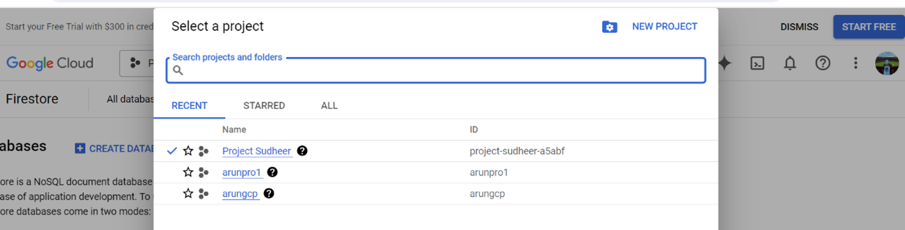

**STEP 2:**

1. By default the firestore mode is in Native mode.
2. For my project, I am going with the native mode.

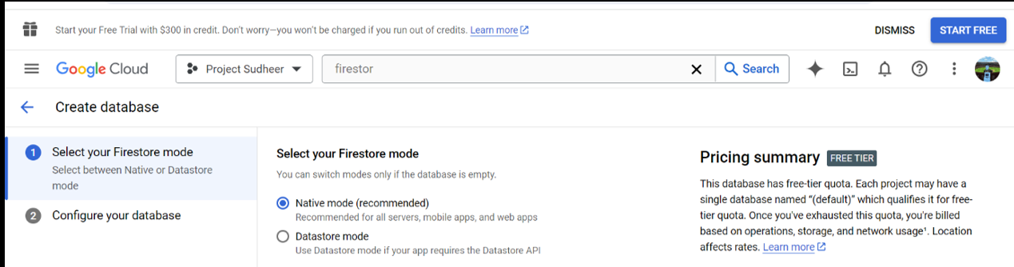

**NATIVE MODE VS DATASTORE MODE**

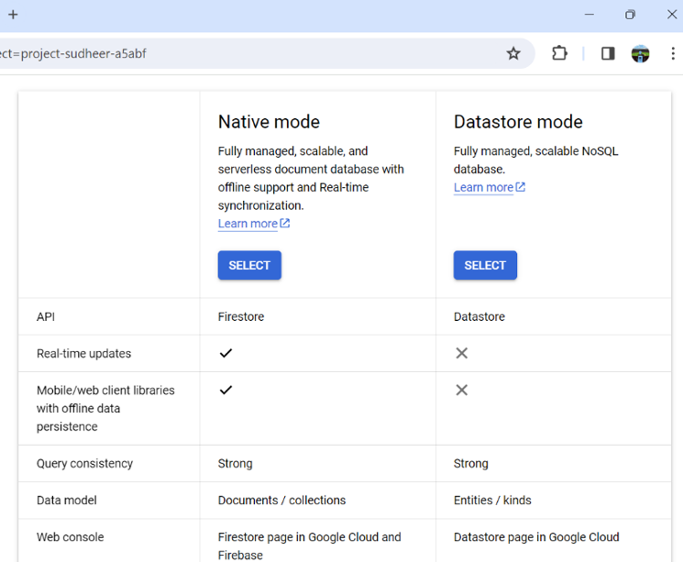

**TASK1 :**

1. Create a firestore database:

* A firestore database named “supe” is created.

GUI method:

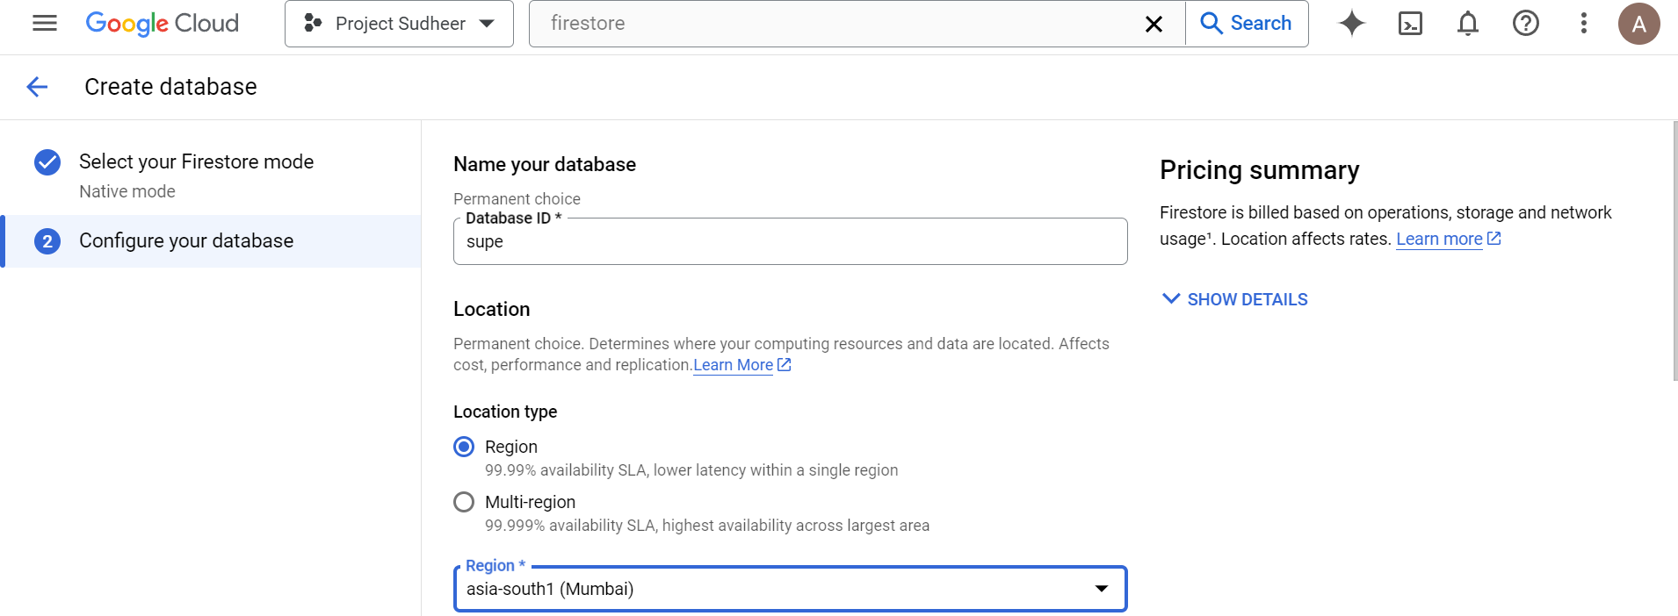

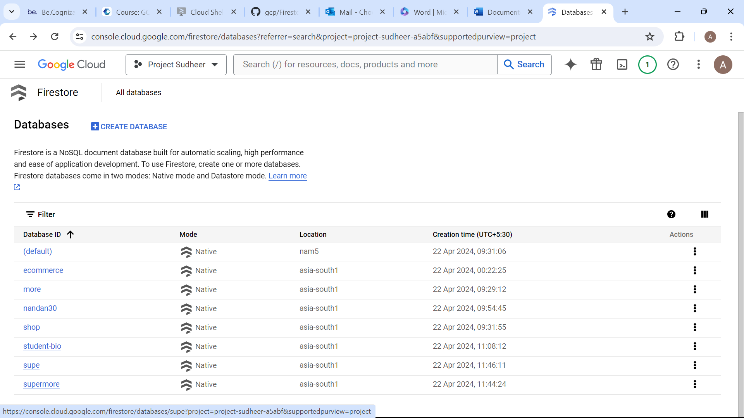

1. A database named ‘supe’ is created
2. Region is set to ‘asia-south1(Mumbai)’ for low latency

Low latency refers to the reduced delay in accessing the data because it’s physically closer to the users, resulting in faster response times for their requests.

CLI method:

Command:

~gcloud firestore databases create --database=supe --location=asia-south1 --type=firestore-native

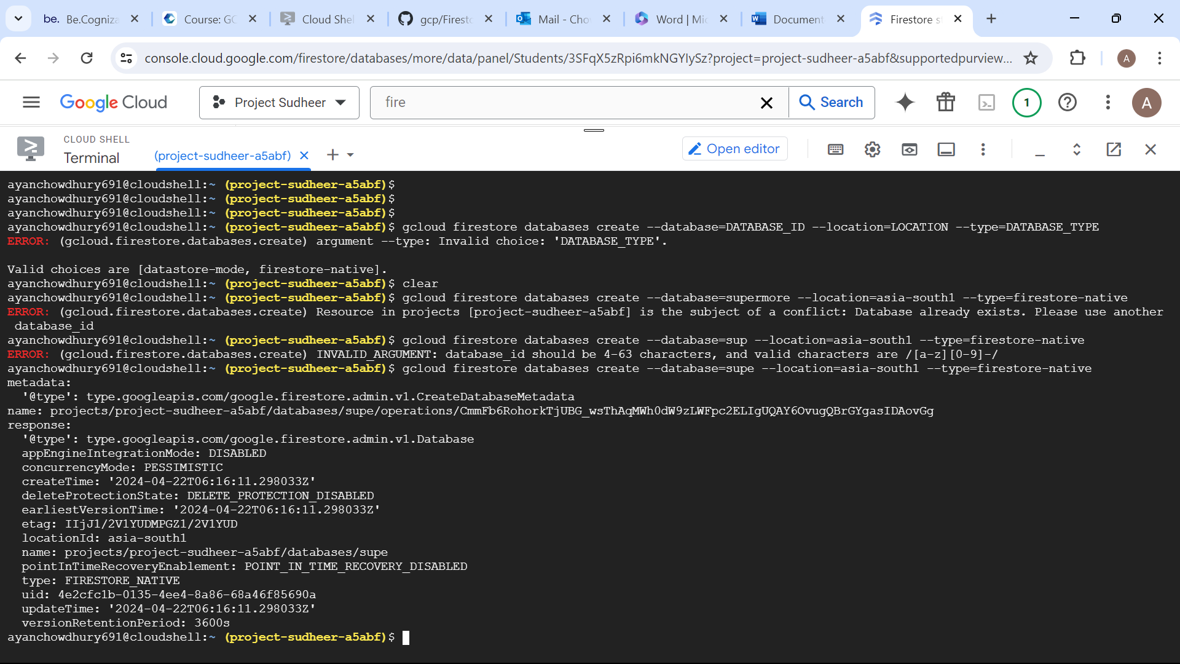

**TASK 2:**

1. Create one collection:

GUI method:

* A collection ID Students has been created.
* Into which fields has name and value Such as
* Emp_ID, Name, Position, Contact in which Email and Phone

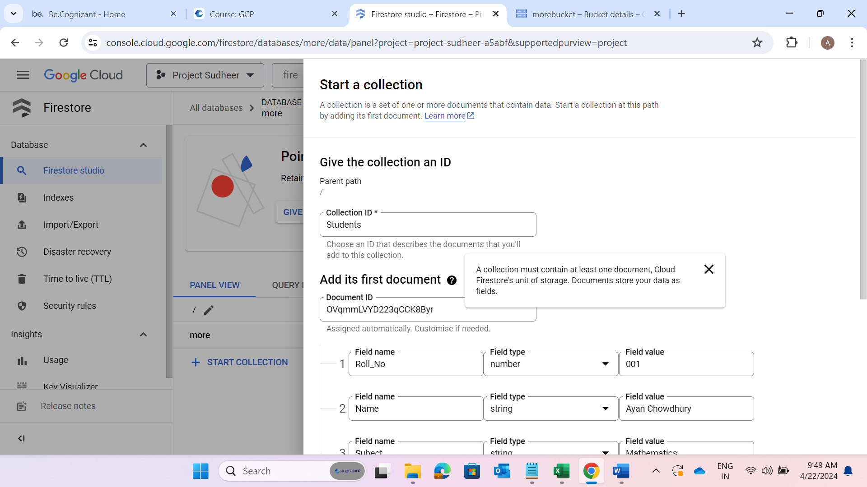

**TASK 3:**

1. Add few documents:

GUI method:

* Here 3 different document ID and content has been entered.
* A document ID is dynamically created on each

\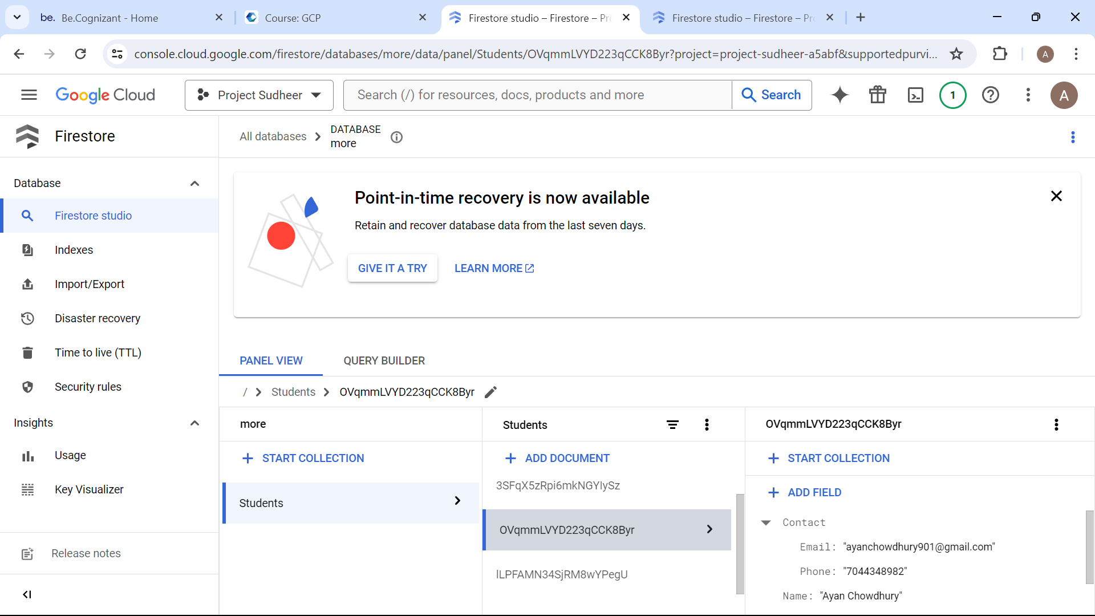

**TASK 4:**

**Python API call:**

Create python script which will read data from a file to firestore

Step-1: Creating a new database named “class”

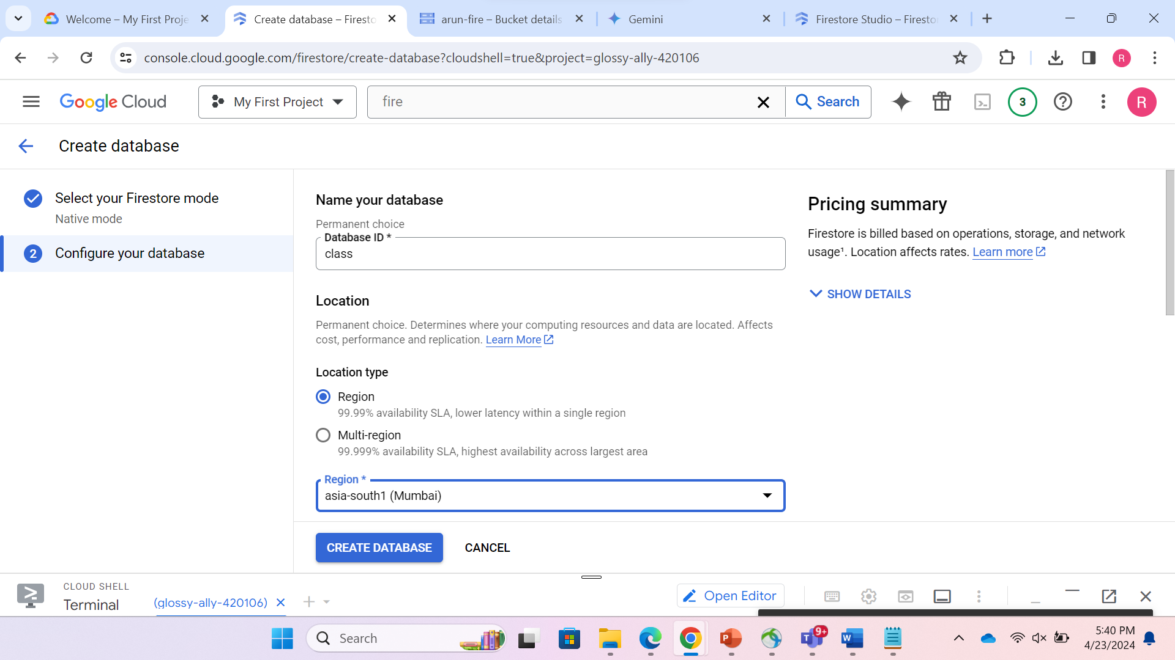

Step-2: Creating a bucket named “classstudents” (using CLI):

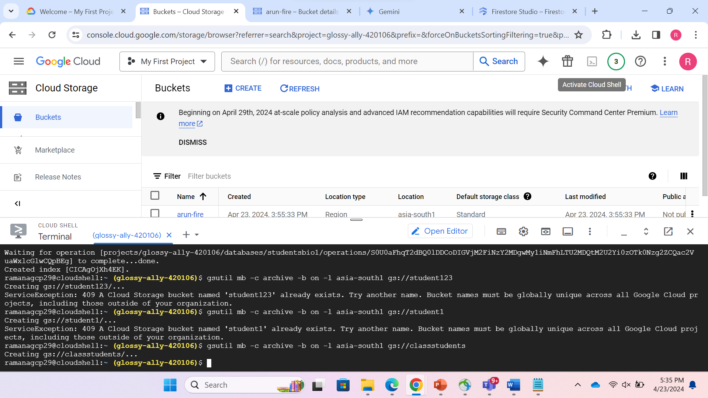

Step-3: Uploading the JSON file named “students.json” :

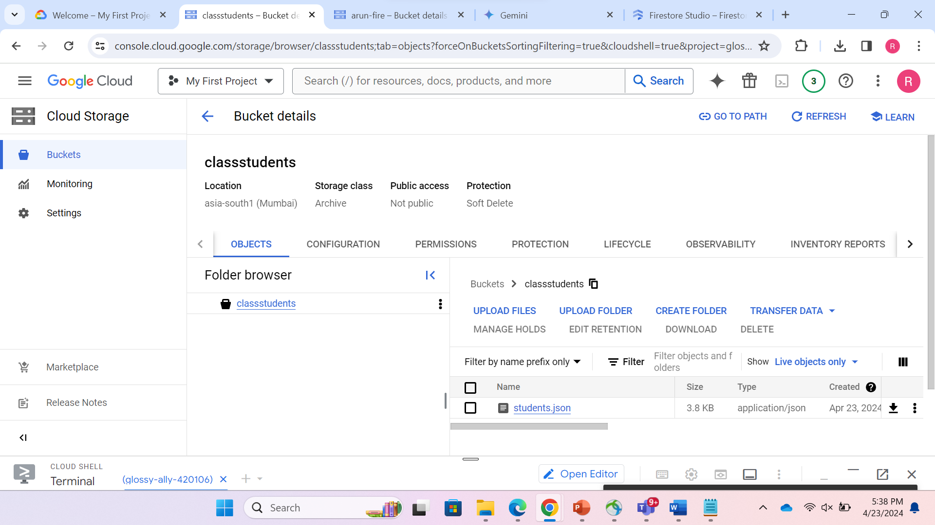

**JSON FILE SAMPLE: students.json**

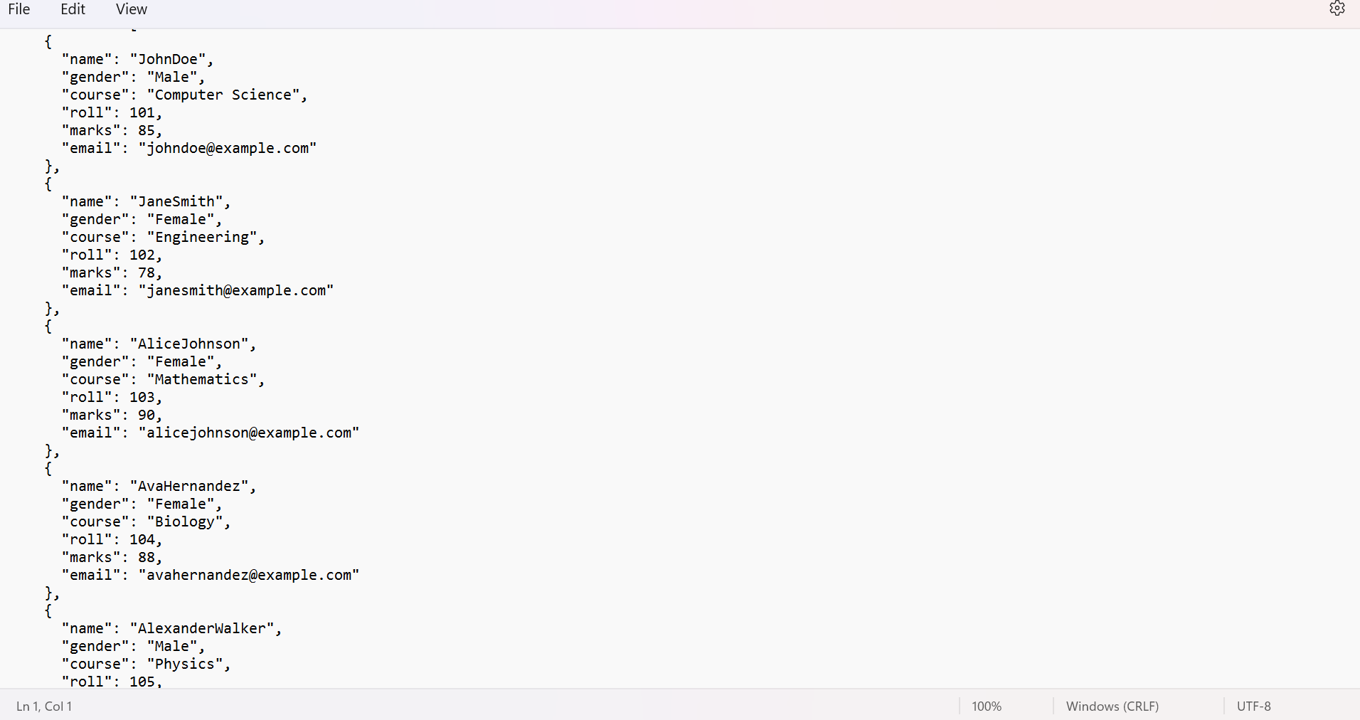

The python script:

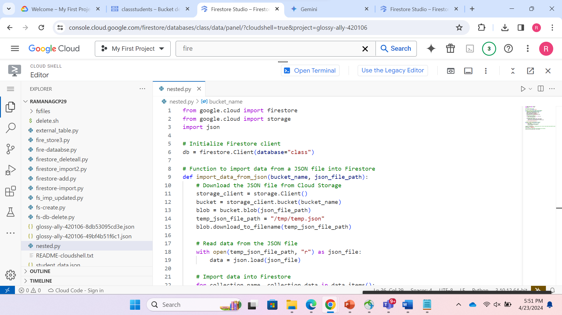Using this python script we read data from a file to firestore

**OUTPUT:**

The data has been imported :

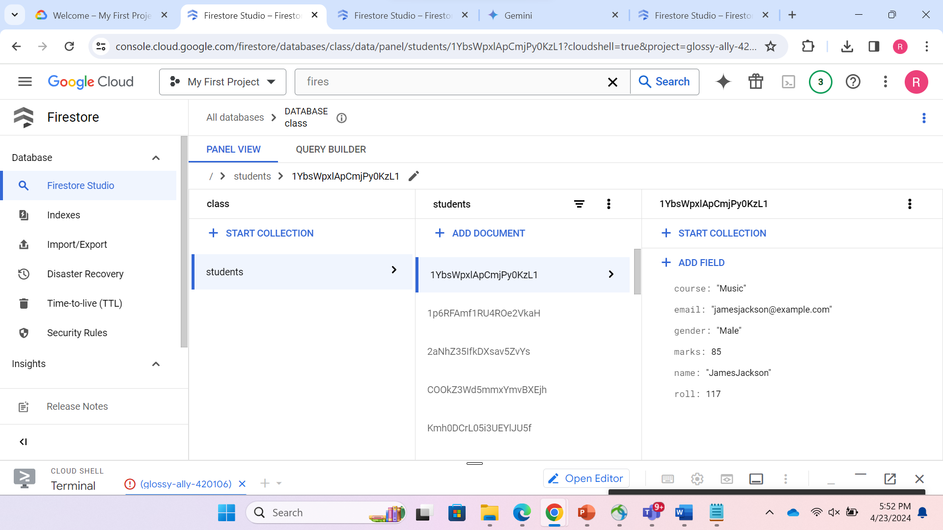

**ADDITIONAL TASKS(using GUI):**

1) Querying: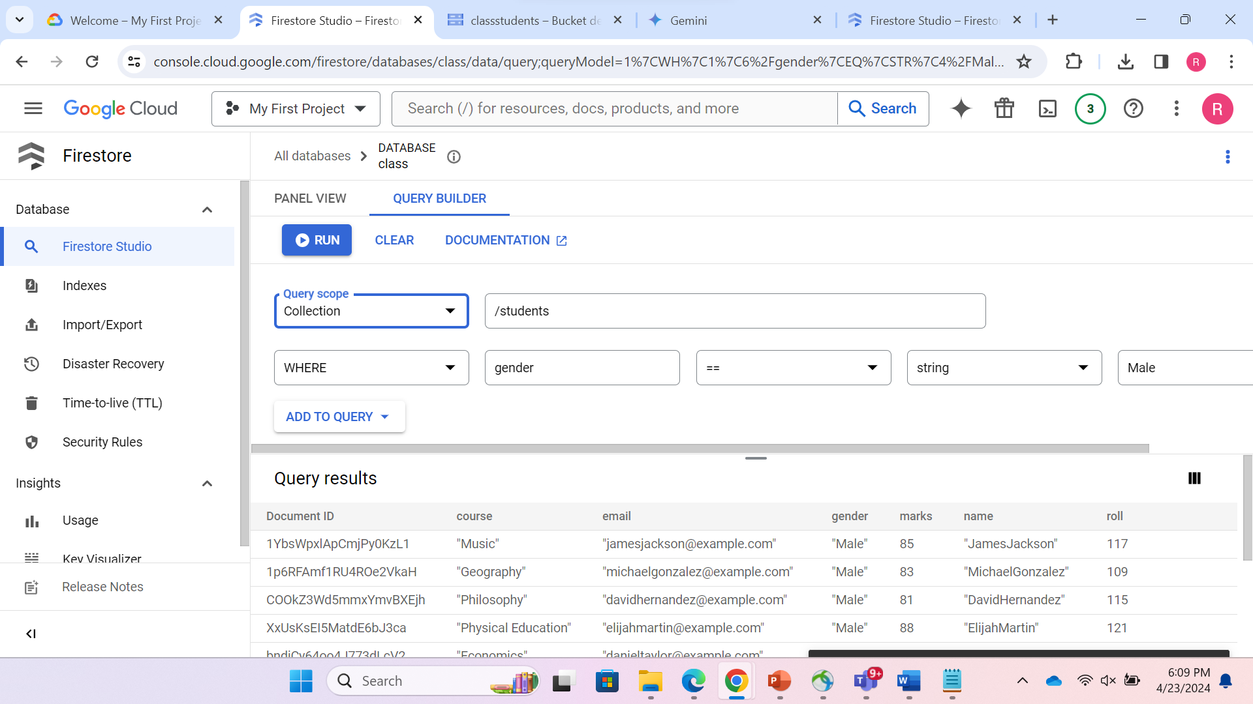Details of the students whose gender is ‘Male’

2) Indexing:

A composite index created from collection ID ‘students’ using 2 fields-gender and marks

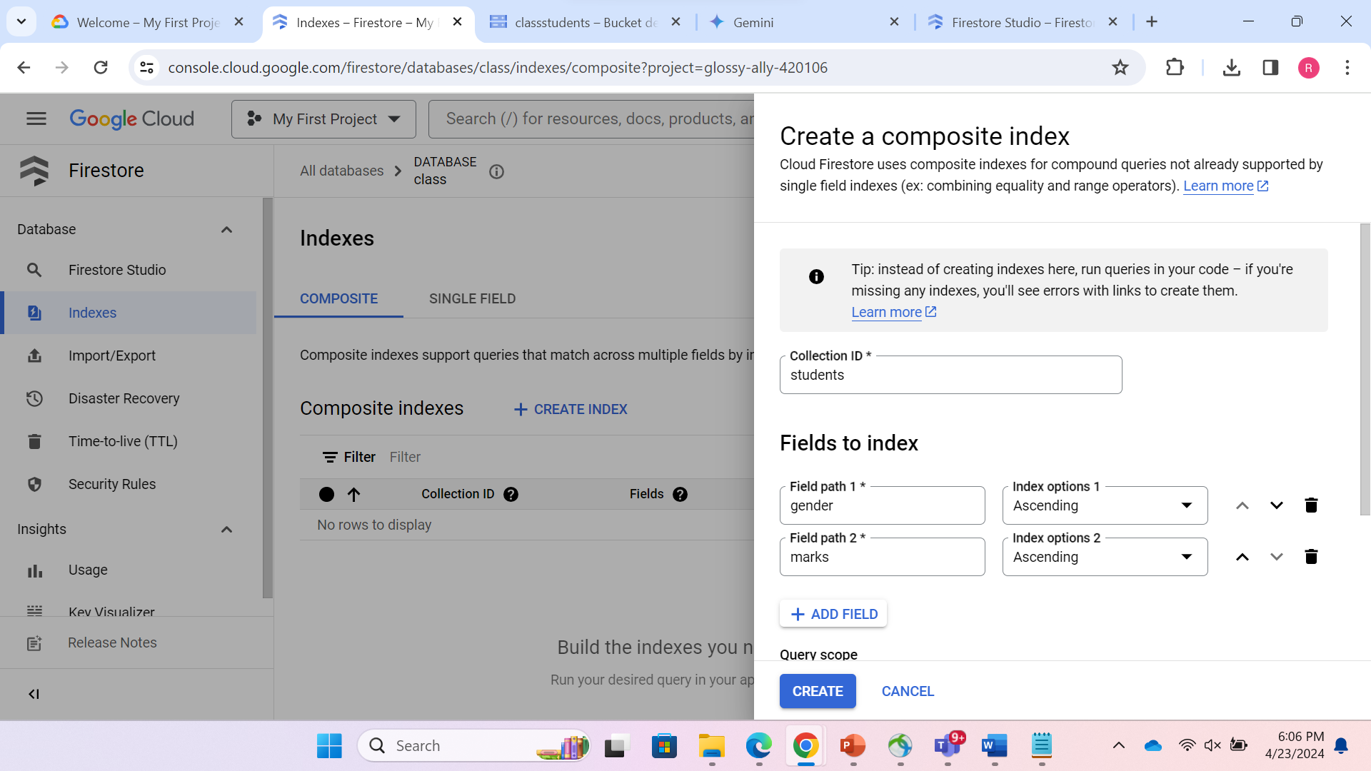

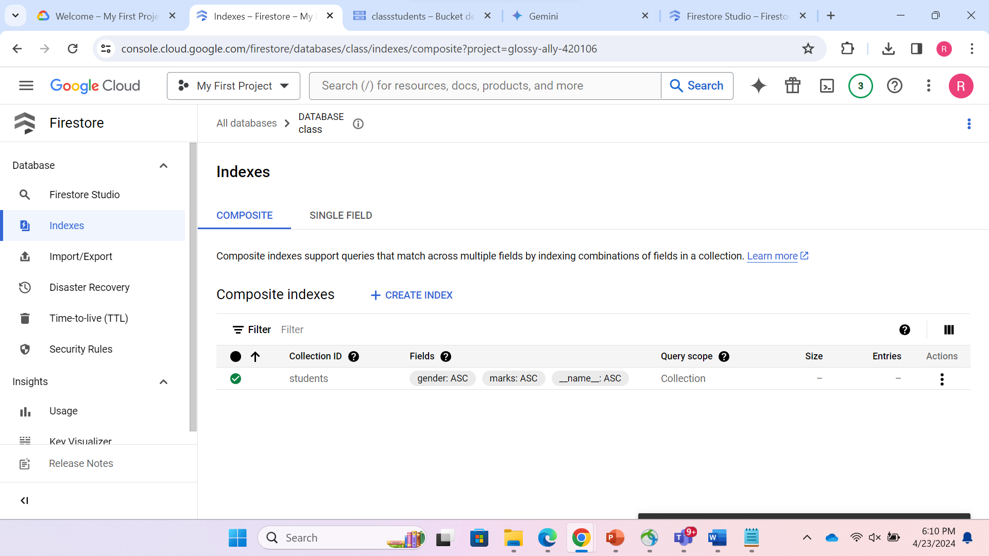

3)Querying(using Indexing):

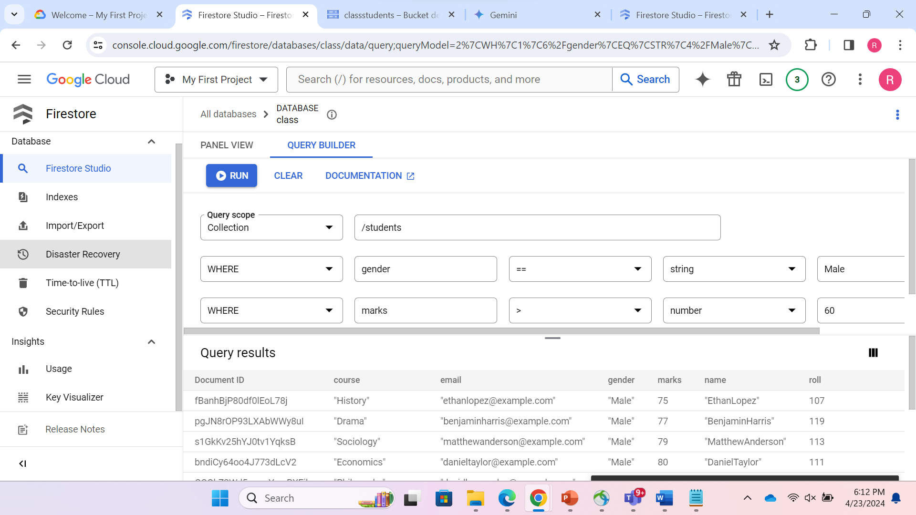

Details of those students whose gender is ‘Male’ and marks > ‘60’

4) IMPORT/EXPORT:

A. Export:

Exporting the data from “class” database and storing in bucket “classstudents”

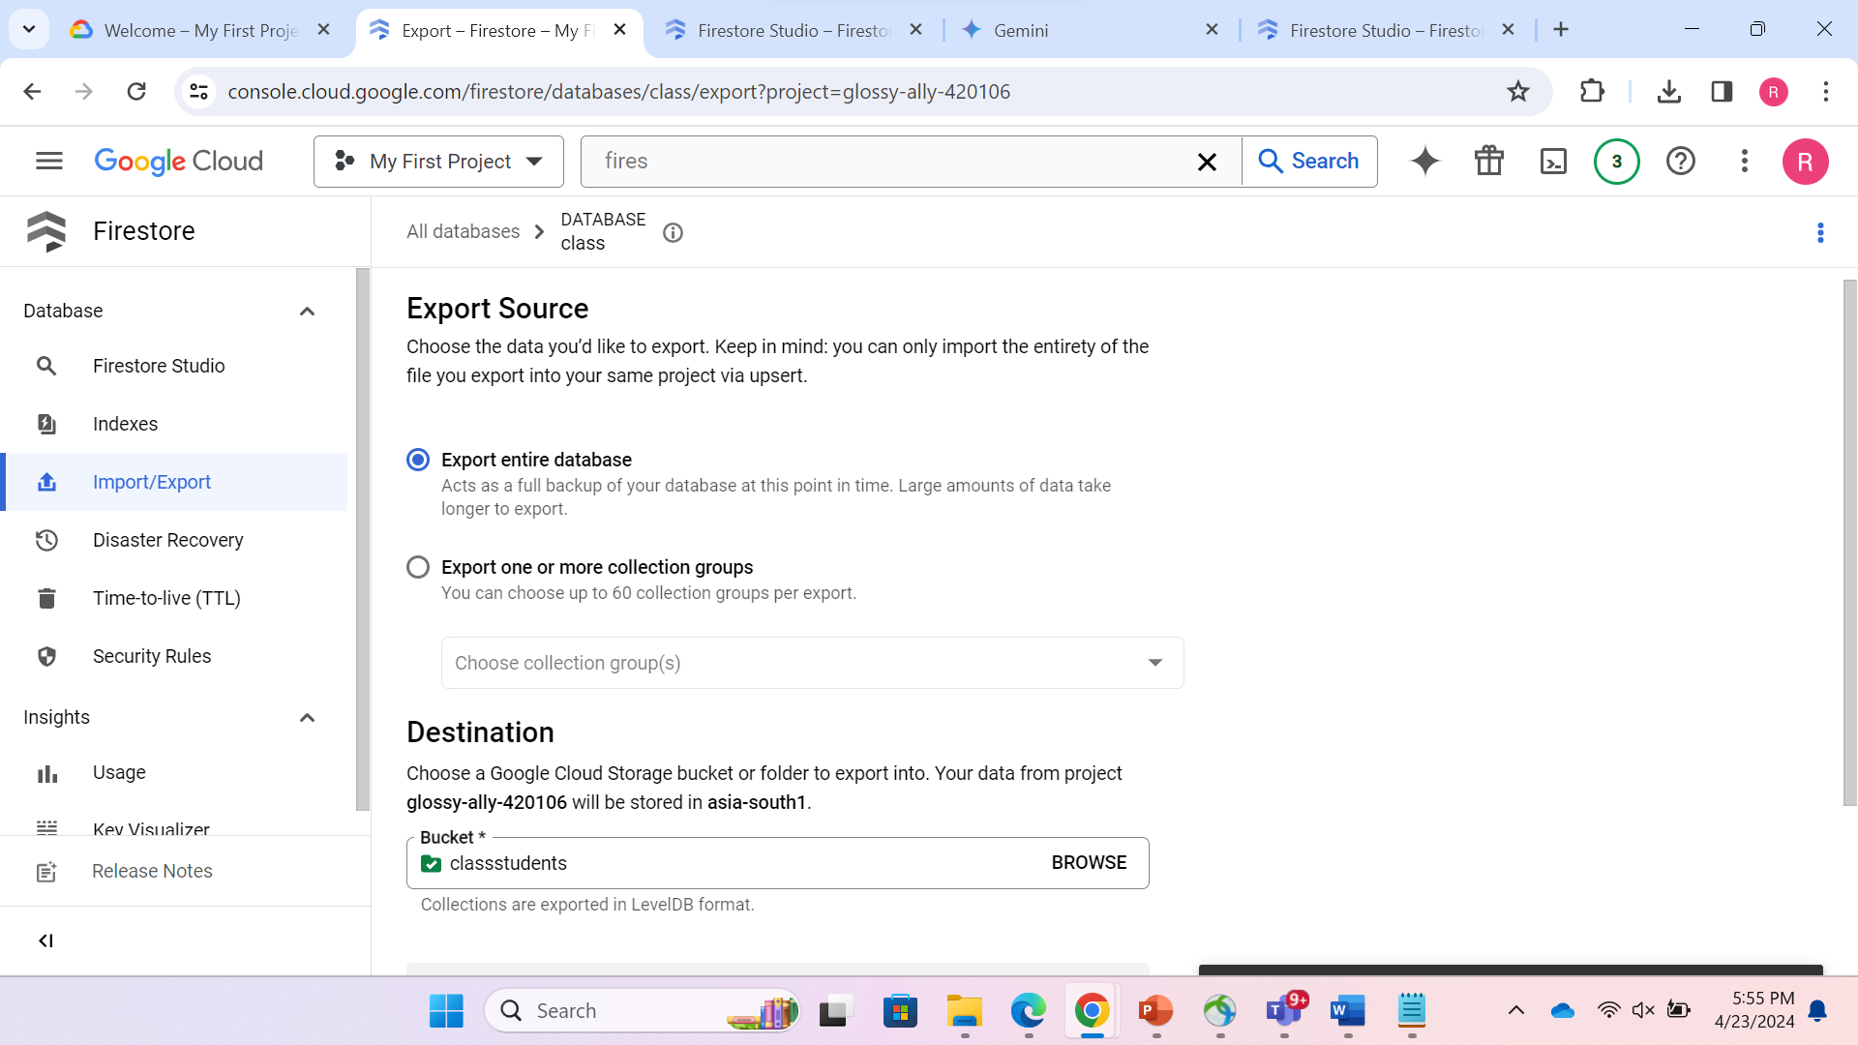

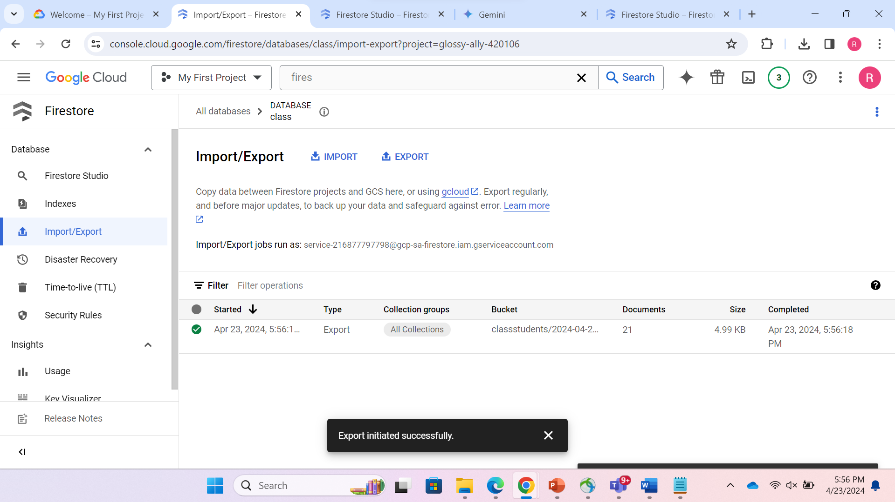So, the Export to bucket is inititated successfully.

B. Import:

Imported in database “class” from the stored bucket where it is exported.

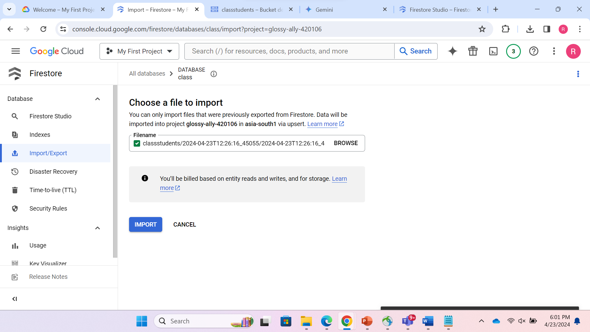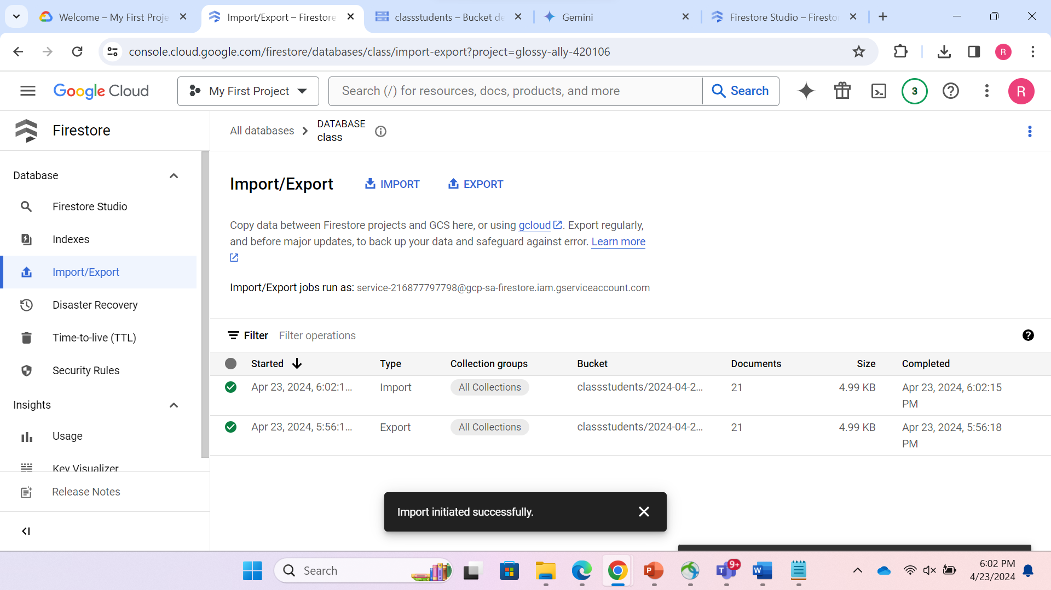So, the Import to “class” database is inititated successfully.

**ADDITIONAL TASKS(using CLI)**

1)Creating a new database using CLI named “gcp3”

Command:

~gcloud firestore databases create --database=gcp3 –location=asia-south1 --type=firestore-native

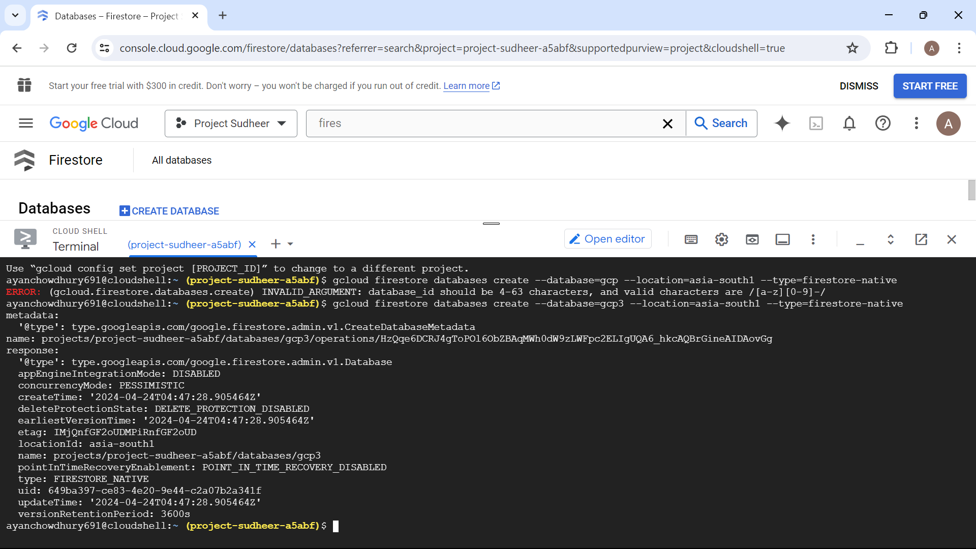

2) Making a collection named “project_group” inside the newly created database “gcp3” and adding 4 documents to it Employee1, Employee2, Employee3, Employee4.

Finally, we are adding 4 fields to these documents namely Age, Emp_id, Name, State

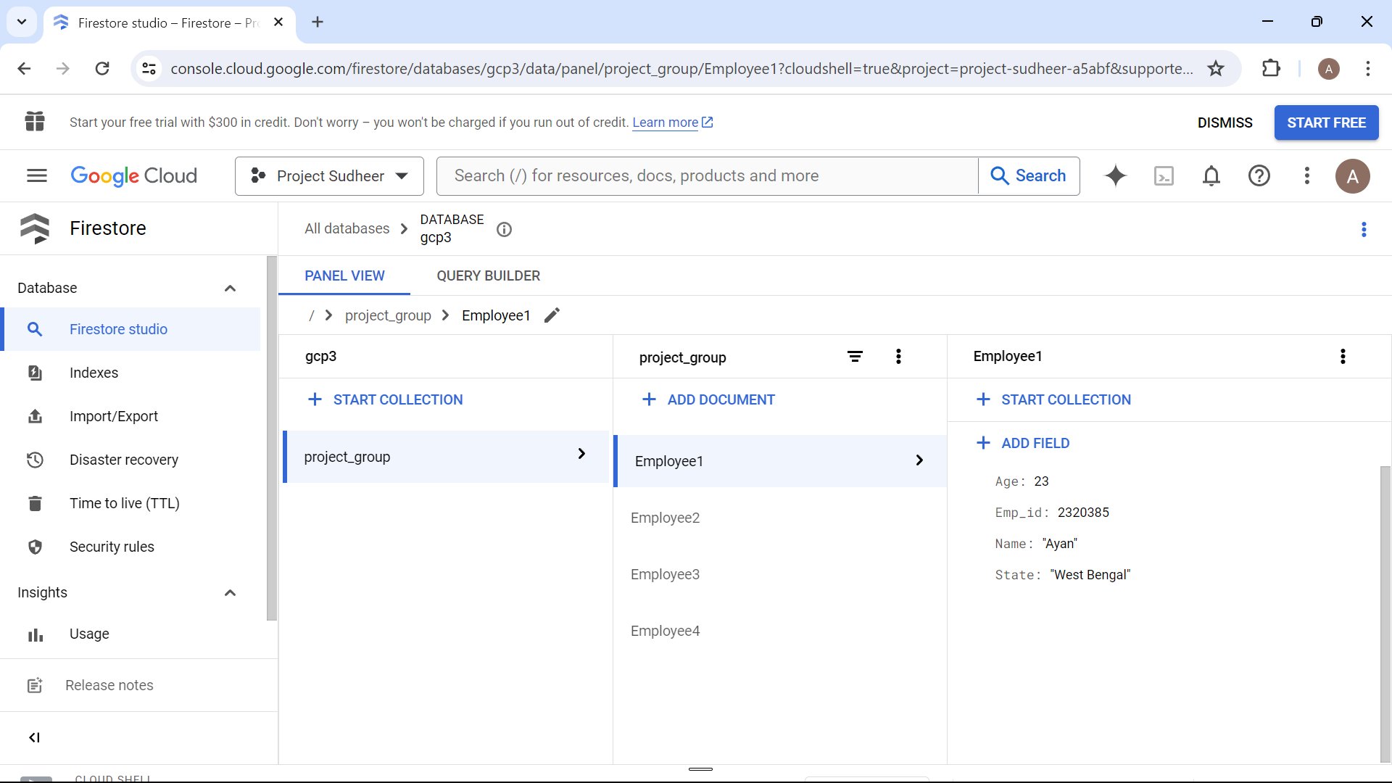

**Now, let's perform some Export/Import operations using CLI**

3) Export:

Now let’s export this database to a bucket named “projectbucketgcp”

Command: gcloud firestore export --database=gcp3 gs://projectbucketgcp

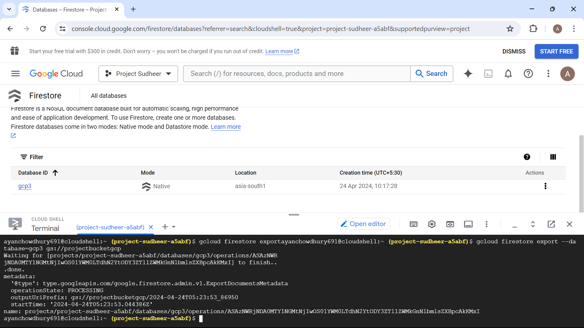

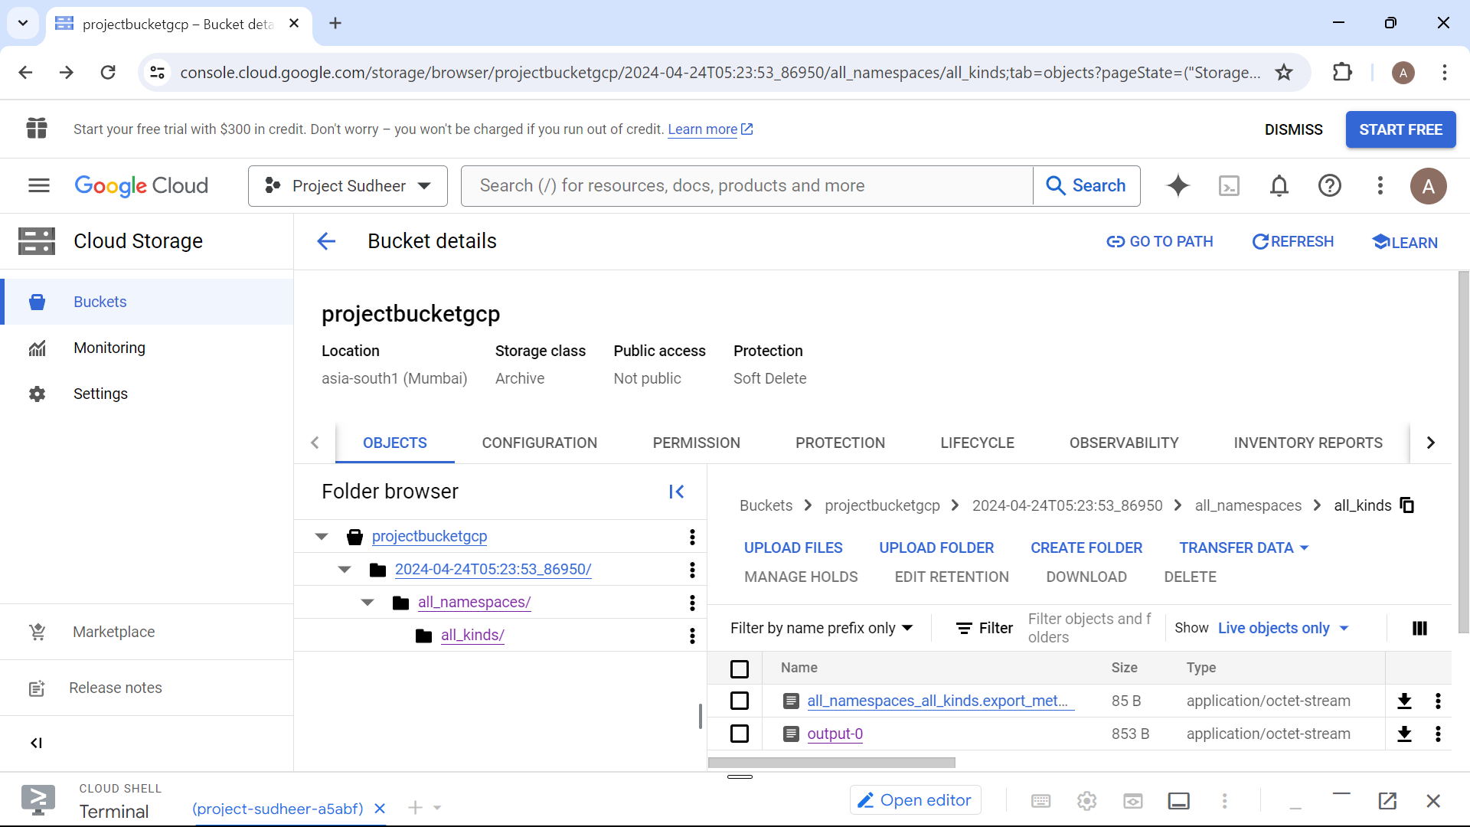The exported database content is stored in bucket named “projectbucketgcp“ under path 2024-04-24T05:23:53_86950/

4) Import:

A new database “primary” is created in which we will import the objects that we stored in the bucket named “projectbucketgcp”

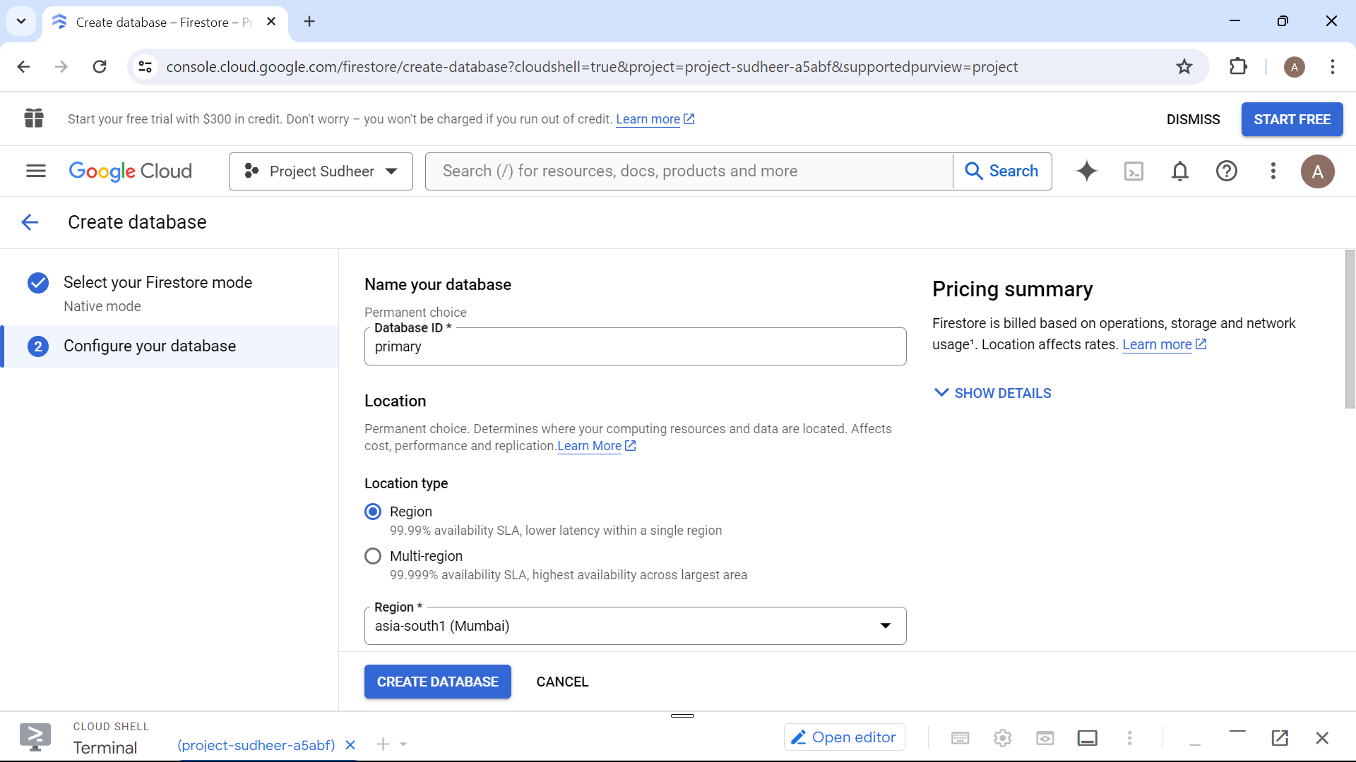

Now, let's import from the bucket:

Command:

gcloud firestore import gs://projectbucketgcp/2024-04- 24T05:23:53_86950 –database=primary

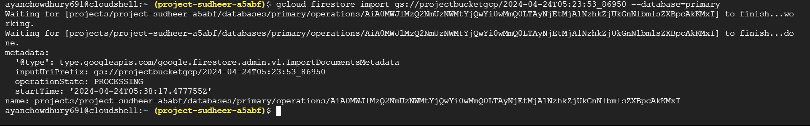

Now, let's check whether the data is imported to the new database “primary” or not:

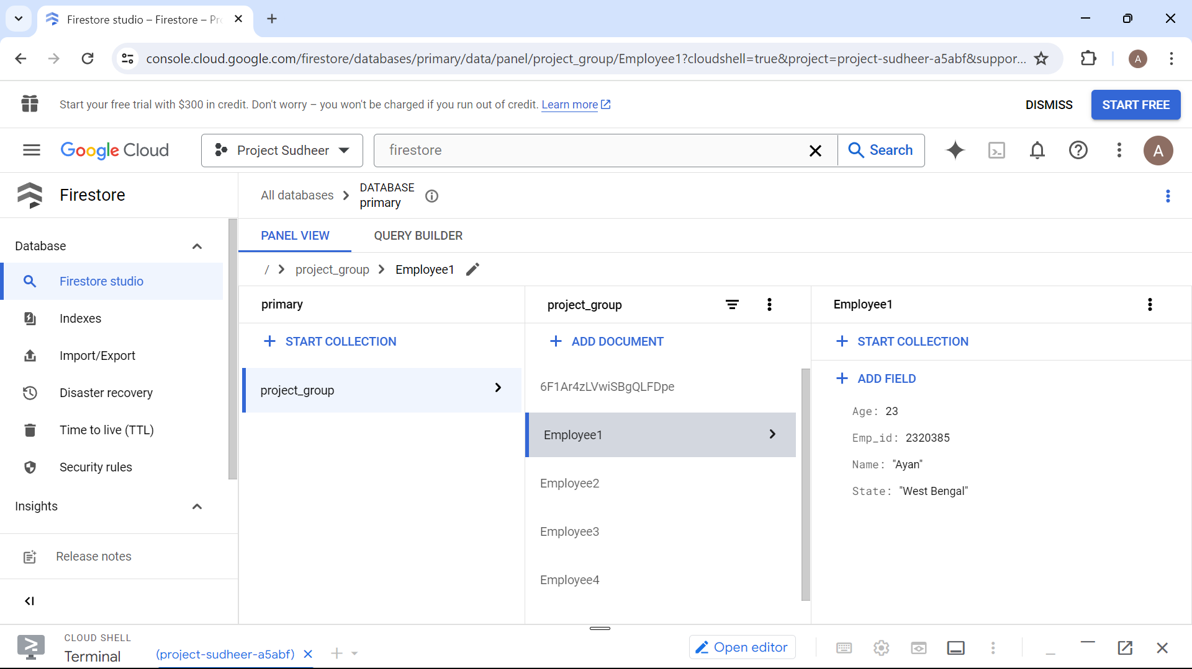So, we can see that the data is imported to the new database successfully.

5) Indexes:

Now, let's perform indexing using the CLI

Command:

~gcloud firestore indexes composite create --database=gcp3 --collection-group=gcp3 --field-config=field-path=State,order=descending --field-config=field-path=Age,order=descending

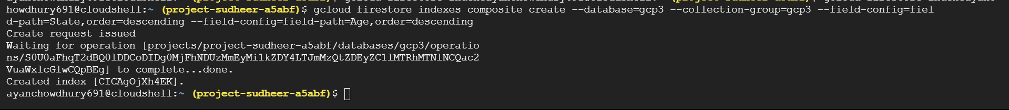

Now, let's check whether the indexes are successfully created or not.

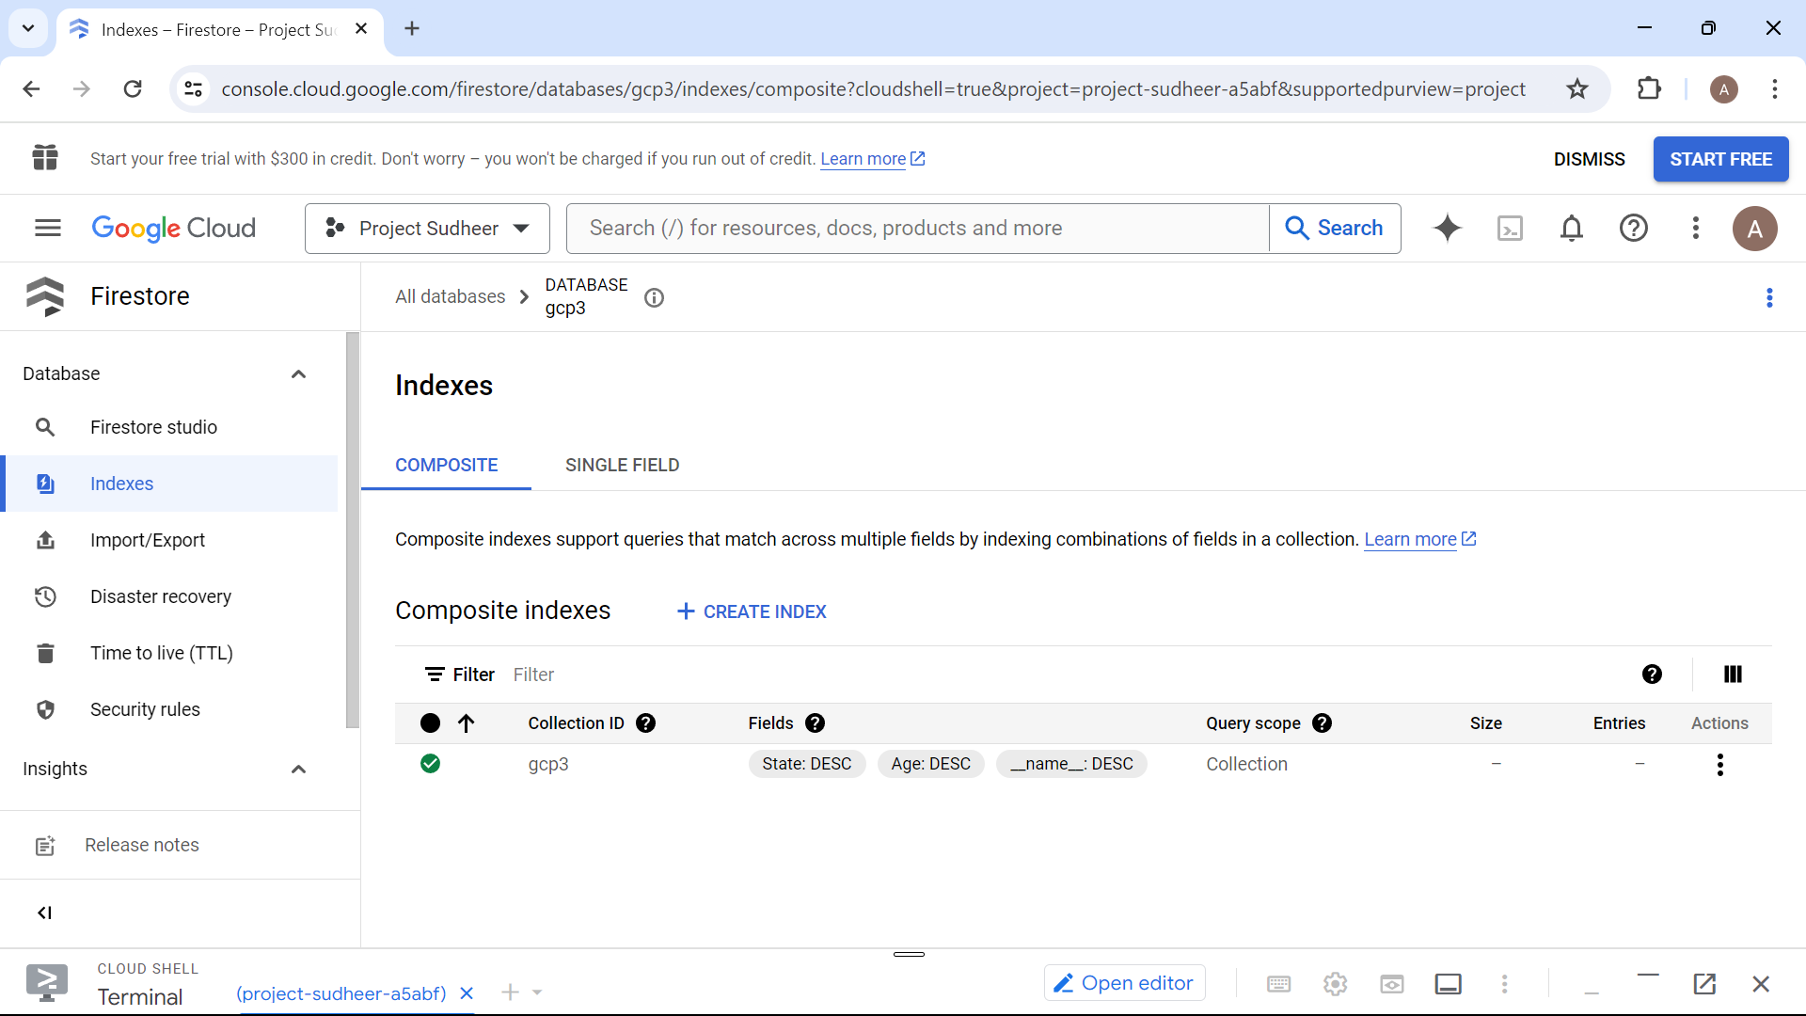So, we can see that it's finally created.

**CRUD operations using** **Python :**

Read file and display it in console:

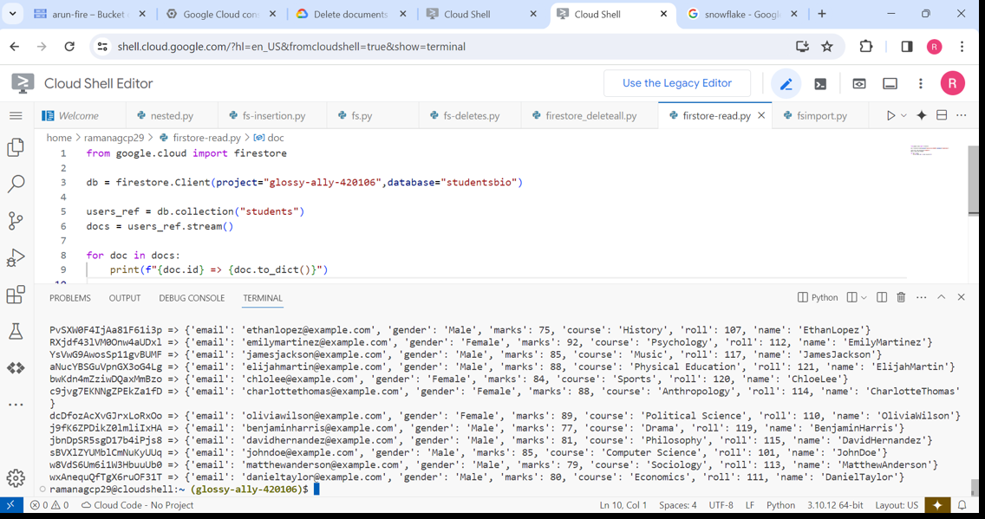

Creating Collection and adding Document:

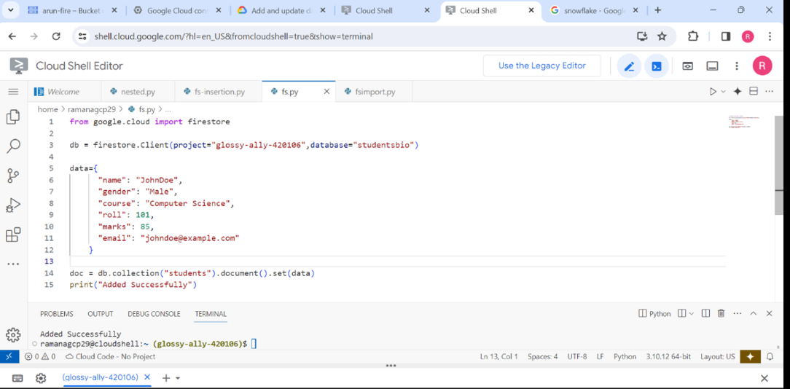

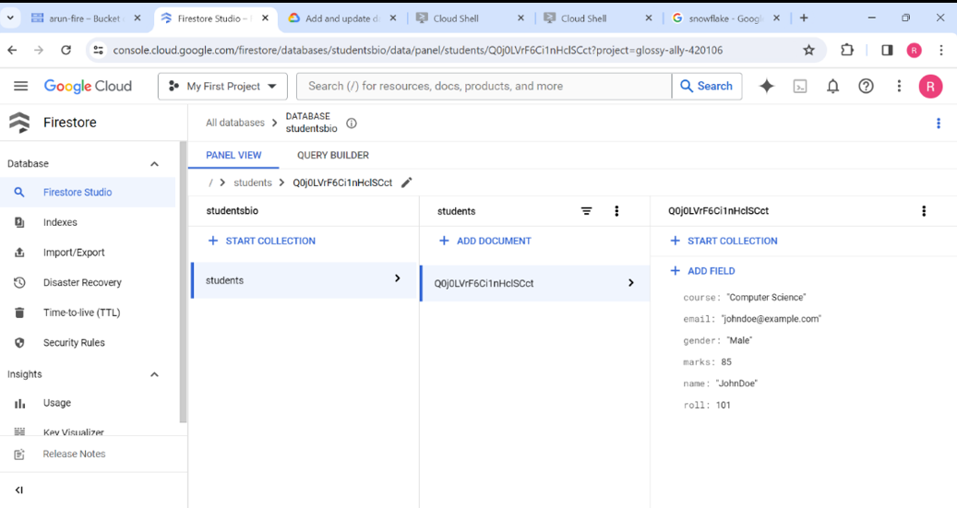So, we can see that a collection named ”students” is created and one document is added.

**Updating few fields inside a document:**

Before updating:

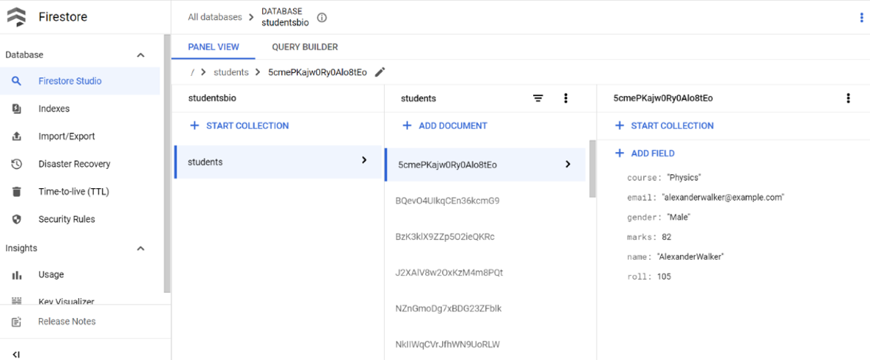

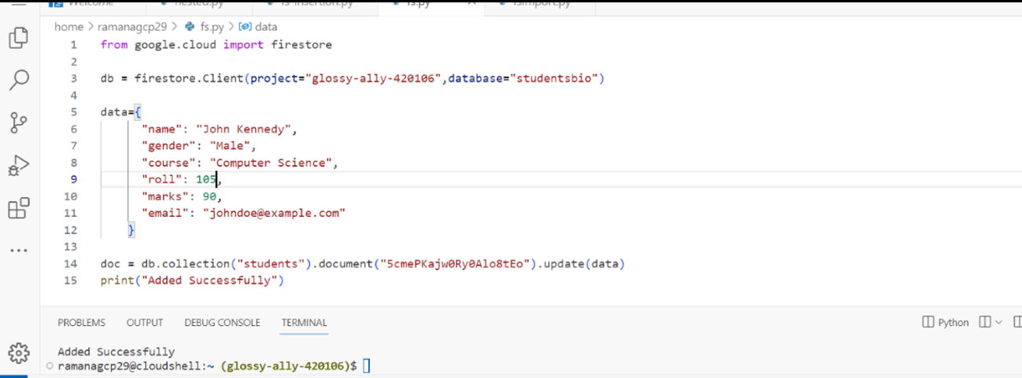

After updating:

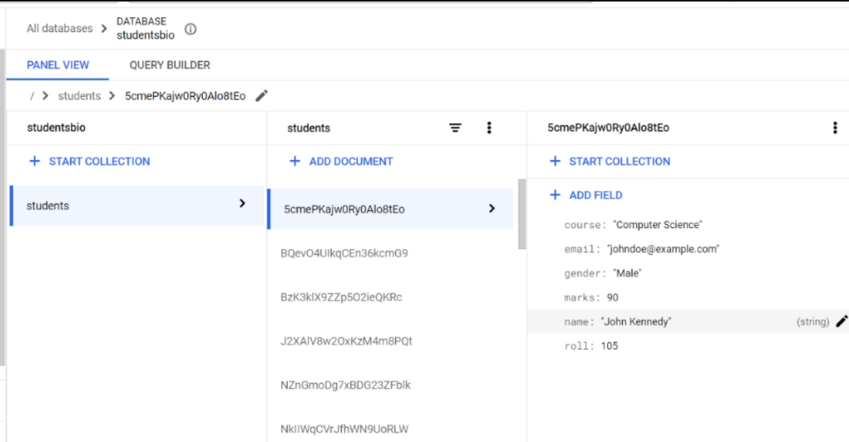So, we can clearly see that all of the fields in the document named

“5cmePKajw0Ry0Alo8tEo” are updated.

**Adding few documents into a collection:**

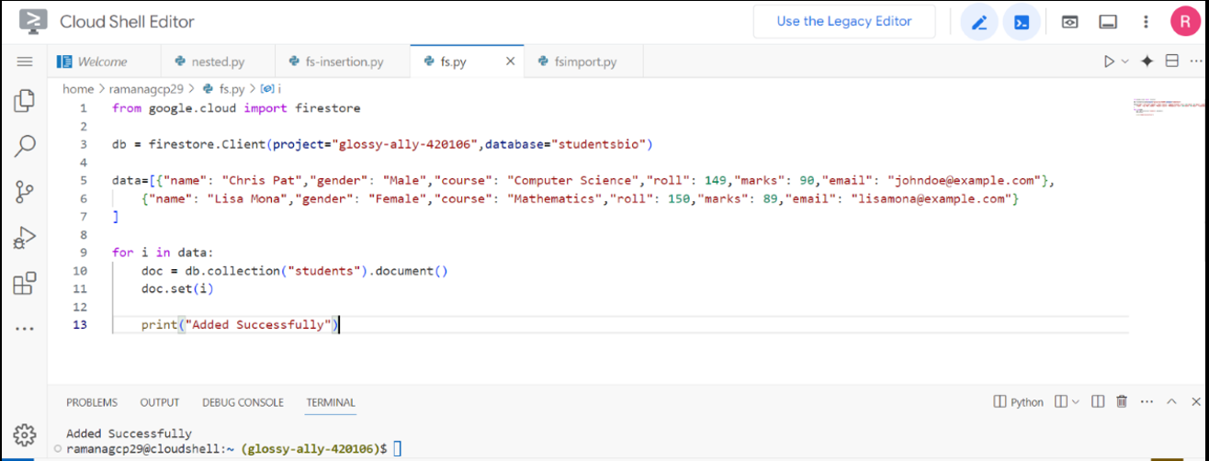

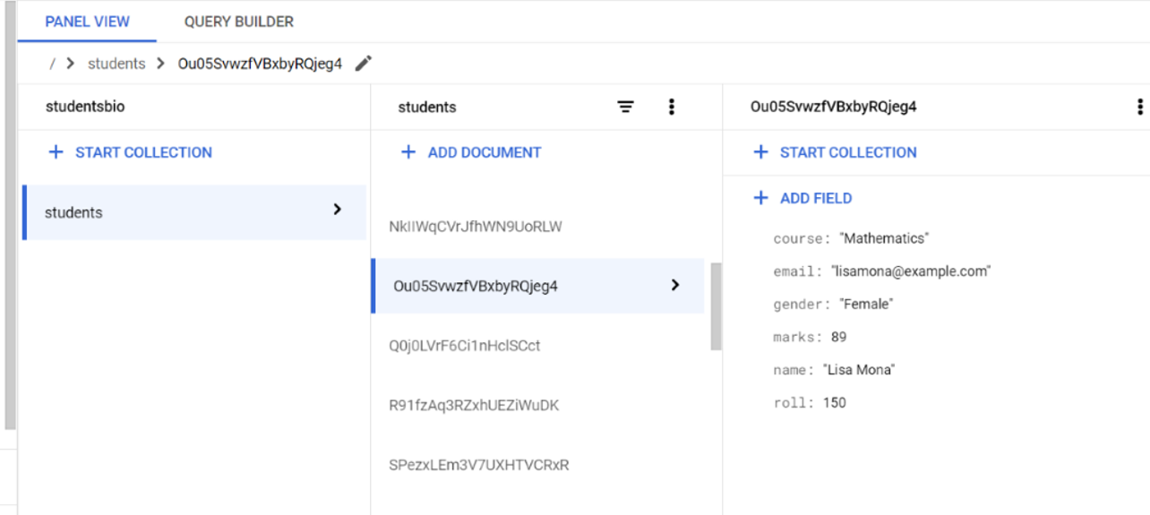

So, we can see that new document named “Ou05SvwzfVBxbyRqjeg4” is added along with the fields

**Now let’s perform some DELETE operations:**

1. Deleting a document:

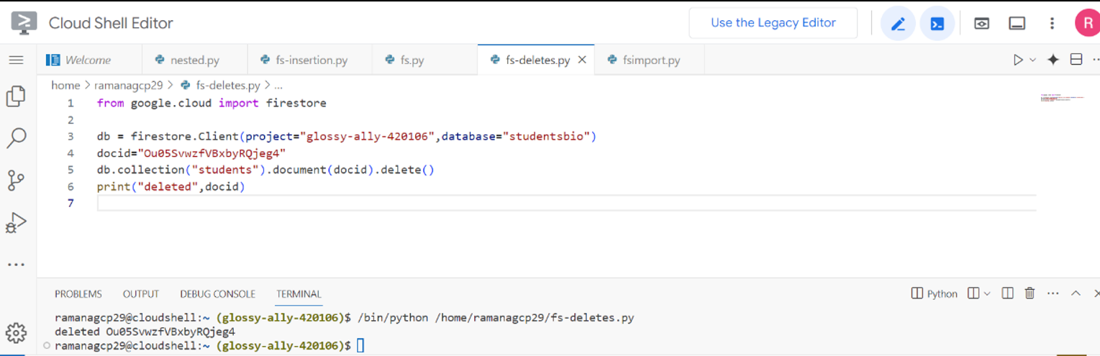

1. Deleting a field from a document:

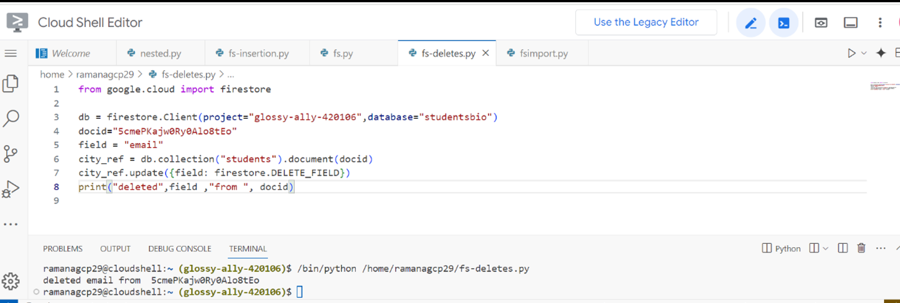

1. Deleting documents in a collection:

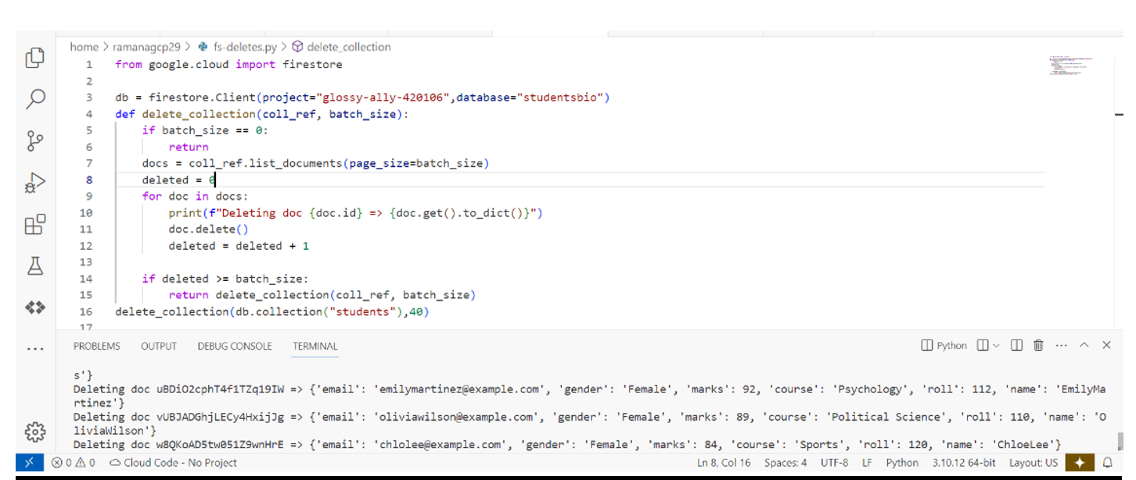

**CONCLUSION:**

Our project successfully explored Google Firestore services, covering database creation, collection management and data import. By leveraging Firestore’s real-time capabilities we can build responsive applications that handle both transactional and analytical workloads. Firestores scalability, security, and ease of use make it a powerful choice for modern applications.